**MY SQL QUERIES**

**All of these Queries were fired in MySQL to recheck and justify the shown data in the Power BI Dashboard**

**COFFEE SHOP SALES PROJECT**

**CONVERT DATE (transaction_date) COLUMN TO PROPER DATE FORMAT**

UPDATE coffee_shop_sales

SET transaction_date = STR_TO_DATE(transaction_date, '%d-%m-%Y');

**ALTER DATE (transaction_date) COLUMN TO DATE DATA TYPE**

ALTER TABLE coffee_shop_sales

MODIFY COLUMN transaction_date DATE;

**CONVERT TIME (transaction_time) COLUMN TO PROPER DATE FORMAT**

UPDATE coffee_shop_sales

SET transaction_time = STR_TO_DATE(transaction_time, '%H:%i:%s');

**ALTER TIME (transaction_time) COLUMN TO DATE DATA TYPE**

ALTER TABLE coffee_shop_sales

MODIFY COLUMN transaction_time TIME;

**DATA TYPES OF DIFFERENT COLUMNS**

DESCRIBE coffee_shop_sales;

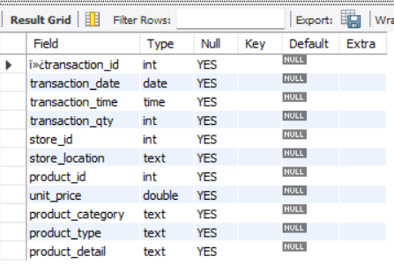

**CHANGE COLUMN NAME `ï»¿transaction_id` to transaction_id**

ALTER TABLE coffee_shop_sales

CHANGE COLUMN `ï»¿transaction_id` transaction_id INT;

**TOTAL SALES**

SELECT ROUND(SUM(unit_price * transaction_qty)) as Total_Sales

FROM coffee_shop_sales

WHERE MONTH(transaction_date) = 5 -- for month of (CM-May)

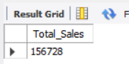

**TOTAL SALES KPI - MOM DIFFERENCE AND MOM GROWTH**

SELECT

MONTH(transaction_date) AS month,

ROUND(SUM(unit_price * transaction_qty)) AS total_sales,

(SUM(unit_price * transaction_qty) - LAG(SUM(unit_price * transaction_qty), 1)

OVER (ORDER BY MONTH(transaction_date))) / LAG(SUM(unit_price * transaction_qty), 1)

OVER (ORDER BY MONTH(transaction_date)) * 100 AS mom_increase_percentage

FROM

coffee_shop_sales

WHERE

MONTH(transaction_date) IN (4, 5) -- for months of April and May

GROUP BY

MONTH(transaction_date)

ORDER BY

MONTH(transaction_date);

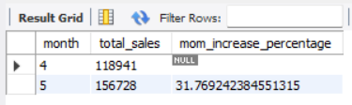

**Explaination**

**SELECT clause:**

* MONTH(transaction_date) AS month: Extracts the month from the transaction_date column and renames it as month.
* ROUND(SUM(unit_price * transaction_qty)) AS total_sales: Calculates the total sales by multiplying unit_price and transaction_qty, then sums the result for each month. The ROUND function rounds the result to the nearest integer.
* (SUM(unit_price * transaction_qty) - LAG(SUM(unit_price * transaction_qty), 1) OVER (ORDER BY MONTH(transaction_date))) / LAG(SUM(unit_price * transaction_qty), 1) OVER (ORDER BY MONTH(transaction_date)) * 100 AS mom_increase_percentage with the functions used:
  + SUM(unit_price * transaction_qty): This calculates the total sales for the current month. It multiplies the unit_price by the transaction_qty for each transaction and then sums up these values.
  + LAG(SUM(unit_price * transaction_qty), 1) OVER (ORDER BY MONTH(transaction_date)): This function retrieves the value of the total sales for the previous month. It uses the LAG window function to get the value of the SUM(unit_price * transaction_qty) from the previous row (previous month) ordered by the transaction_date.
  + (SUM(unit_price * transaction_qty) - LAG(SUM(unit_price * transaction_qty), 1) OVER (ORDER BY MONTH(transaction_date))): This part calculates the difference between the total sales of the current month and the total sales of the previous month.
  + LAG(SUM(unit_price * transaction_qty), 1) OVER (ORDER BY MONTH(transaction_date)): This function retrieves the value of the total sales for the previous month again. It's used in the denominator to calculate the percentage increase.
  + (SUM(unit_price * transaction_qty) - LAG(SUM(unit_price * transaction_qty), 1) OVER (ORDER BY MONTH(transaction_date))) / LAG(SUM(unit_price * transaction_qty), 1) OVER (ORDER BY MONTH(transaction_date)): This calculates the ratio of the difference in sales between the current and previous months to the total sales of the previous month. It represents the percentage increase or decrease in sales compared to the previous month.
  + 100: This part multiplies the ratio by 100 to convert it to a percentage.
* FROM clause:

coffee_shop_sales: Specifies the table from which data is being selected.

* WHERE clause:

MONTH(transaction_date) IN (4, 5): Filters the data to include only transactions from April and May.

* GROUP BY clause:

MONTH(transaction_date): Groups the results by month.

* ORDER BY clause:

MONTH(transaction_date): Orders the results by month.

**TOTAL ORDERS**

SELECT COUNT(transaction_id) as Total_Orders

FROM coffee_shop_sales

WHERE MONTH (transaction_date)= 5 -- for month of (CM-May)

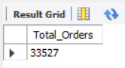

**TOTAL ORDERS KPI - MOM DIFFERENCE AND MOM GROWTH**

SELECT

MONTH(transaction_date) AS month,

ROUND(COUNT(transaction_id)) AS total_orders,

(COUNT(transaction_id) - LAG(COUNT(transaction_id), 1)

OVER (ORDER BY MONTH(transaction_date))) / LAG(COUNT(transaction_id), 1)

OVER (ORDER BY MONTH(transaction_date)) * 100 AS mom_increase_percentage

FROM

coffee_shop_sales

WHERE

MONTH(transaction_date) IN (4, 5) -- for April and May

GROUP BY

MONTH(transaction_date)

ORDER BY

MONTH(transaction_date);

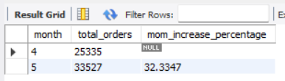

**TOTAL QUANTITY SOLD**

SELECT SUM(transaction_qty) as Total_Quantity_Sold

FROM coffee_shop_sales

WHERE MONTH(transaction_date) = 5 -- for month of (CM-May)

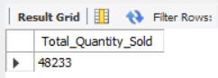

**TOTAL QUANTITY SOLD KPI - MOM DIFFERENCE AND MOM GROWTH**

SELECT

MONTH(transaction_date) AS month,

ROUND(SUM(transaction_qty)) AS total_quantity_sold,

(SUM(transaction_qty) - LAG(SUM(transaction_qty), 1)

OVER (ORDER BY MONTH(transaction_date))) / LAG(SUM(transaction_qty), 1)

OVER (ORDER BY MONTH(transaction_date)) * 100 AS mom_increase_percentage

FROM

coffee_shop_sales

WHERE

MONTH(transaction_date) IN (4, 5) -- for April and May

GROUP BY

MONTH(transaction_date)

ORDER BY

MONTH(transaction_date);

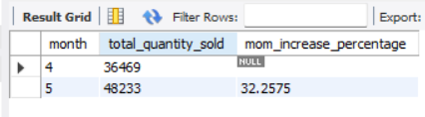

**CALENDAR TABLE – DAILY SALES, QUANTITY and TOTAL ORDERS**

SELECT

SUM(unit_price * transaction_qty) AS total_sales,

SUM(transaction_qty) AS total_quantity_sold,

COUNT(transaction_id) AS total_orders

FROM

coffee_shop_sales

WHERE

transaction_date = '2023-05-18'; --For 18 May 2023

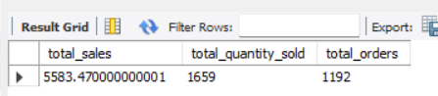

***If you want to get exact Rounded off values then use below query to get the result:***

SELECT

CONCAT(ROUND(SUM(unit_price * transaction_qty) / 1000, 1),'K') AS total_sales,

CONCAT(ROUND(COUNT(transaction_id) / 1000, 1),'K') AS total_orders,

CONCAT(ROUND(SUM(transaction_qty) / 1000, 1),'K') AS total_quantity_sold

FROM

coffee_shop_sales

WHERE

transaction_date = '2023-05-18'; --For 18 May 2023

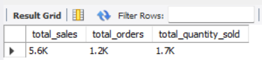

**SALES TREND OVER PERIOD**

SELECT AVG(total_sales) AS average_sales

FROM (

SELECT

SUM(unit_price * transaction_qty) AS total_sales

FROM

coffee_shop_sales

WHERE

MONTH(transaction_date) = 5 -- Filter for May

GROUP BY

transaction_date

) AS internal_query;

***Query Explanation:***

* This inner subquery calculates the total sales (unit_price * transaction_qty) for each date in May. It filters the data to include only transactions that occurred in May by using the MONTH() function to extract the month from the transaction_date column and filtering for May (month number 5).
* The GROUP BY clause groups the data by transaction_date, ensuring that the total sales are aggregated for each individual date in May.
* The outer query calculates the average of the total sales over all dates in May. It references the result of the inner subquery as a derived table named internal_query.
* The AVG() function calculates the average of the total_sales column from the derived table, giving us the average sales for May.

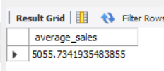

**DAILY SALES FOR MONTH SELECTED**

SELECT

DAY(transaction_date) AS day_of_month,

ROUND(SUM(unit_price * transaction_qty),1) AS total_sales

FROM

coffee_shop_sales

WHERE

MONTH(transaction_date) = 5 -- Filter for May

GROUP BY

DAY(transaction_date)

ORDER BY

DAY(transaction_date);

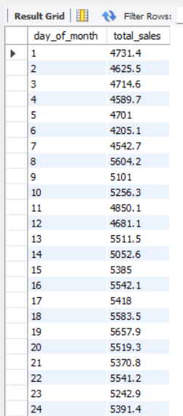 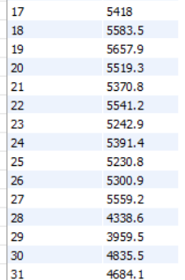

***COMPARING DAILY SALES WITH AVERAGE SALES – IF GREATER THAN “ABOVE AVERAGE” and LESSER THAN “BELOW AVERAGE”***

SELECT

day_of_month,

CASE

WHEN total_sales > avg_sales THEN 'Above Average'

WHEN total_sales < avg_sales THEN 'Below Average'

ELSE 'Average'

END AS sales_status,

total_sales

FROM (

SELECT

DAY(transaction_date) AS day_of_month,

SUM(unit_price * transaction_qty) AS total_sales,

AVG(SUM(unit_price * transaction_qty)) OVER () AS avg_sales

FROM

coffee_shop_sales

WHERE

MONTH(transaction_date) = 5 -- Filter for May

GROUP BY

DAY(transaction_date)

) AS sales_data

ORDER BY

day_of_month;

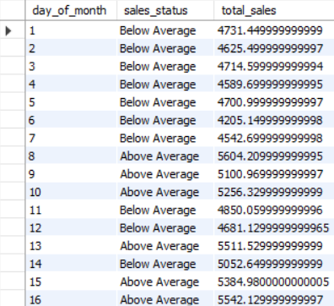 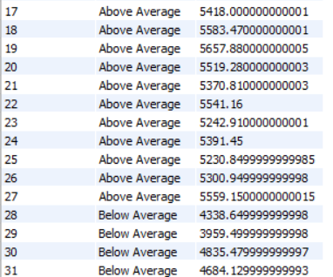

**SALES BY WEEKDAY / WEEKEND:**

SELECT

CASE

WHEN DAYOFWEEK(transaction_date) IN (1, 7) THEN 'Weekends'

ELSE 'Weekdays'

END AS day_type,

ROUND(SUM(unit_price * transaction_qty),2) AS total_sales

FROM

coffee_shop_sales

WHERE

MONTH(transaction_date) = 5 -- Filter for May

GROUP BY

CASE

WHEN DAYOFWEEK(transaction_date) IN (1, 7) THEN 'Weekends'

ELSE 'Weekdays'

END;

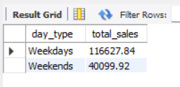

**SALES BY STORE LOCATION**

SELECT

store_location,

SUM(unit_price * transaction_qty) as Total_Sales

FROM coffee_shop_sales

WHERE

MONTH(transaction_date) =5

GROUP BY store_location

ORDER BY SUM(unit_price * transaction_qty) DESC

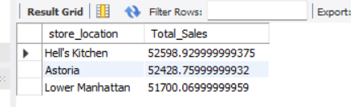

**SALES BY PRODUCT CATEGORY**

SELECT

product_category,

ROUND(SUM(unit_price * transaction_qty),1) as Total_Sales

FROM coffee_shop_sales

WHERE

MONTH(transaction_date) = 5

GROUP BY product_category

ORDER BY SUM(unit_price * transaction_qty) DESC

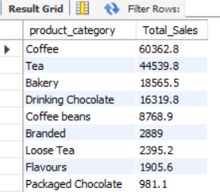

**SALES BY PRODUCTS (TOP 10)**

SELECT

product_type,

ROUND(SUM(unit_price * transaction_qty),1) as Total_Sales

FROM coffee_shop_sales

WHERE

MONTH(transaction_date) = 5

GROUP BY product_type

ORDER BY SUM(unit_price * transaction_qty) DESC

LIMIT 10

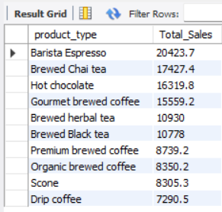

**SALES BY DAY | HOUR**

SELECT

ROUND(SUM(unit_price * transaction_qty)) AS Total_Sales,

SUM(transaction_qty) AS Total_Quantity,

COUNT(*) AS Total_Orders

FROM

coffee_shop_sales

WHERE

DAYOFWEEK(transaction_date) = 3 -- Filter for Tuesday (1 is Sunday, 2 is Monday, ..., 7 is Saturday)

AND HOUR(transaction_time) = 8 -- Filter for hour number 8

AND MONTH(transaction_date) = 5; -- Filter for May (month number 5)

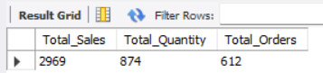

***TO GET SALES FROM MONDAY TO SUNDAY FOR MONTH OF MAY***

SELECT

CASE

WHEN DAYOFWEEK(transaction_date) = 2 THEN 'Monday'

WHEN DAYOFWEEK(transaction_date) = 3 THEN 'Tuesday'

WHEN DAYOFWEEK(transaction_date) = 4 THEN 'Wednesday'

WHEN DAYOFWEEK(transaction_date) = 5 THEN 'Thursday'

WHEN DAYOFWEEK(transaction_date) = 6 THEN 'Friday'

WHEN DAYOFWEEK(transaction_date) = 7 THEN 'Saturday'

ELSE 'Sunday'

END AS Day_of_Week,

ROUND(SUM(unit_price * transaction_qty)) AS Total_Sales

FROM

coffee_shop_sales

WHERE

MONTH(transaction_date) = 5 -- Filter for May (month number 5)

GROUP BY

CASE

WHEN DAYOFWEEK(transaction_date) = 2 THEN 'Monday'

WHEN DAYOFWEEK(transaction_date) = 3 THEN 'Tuesday'

WHEN DAYOFWEEK(transaction_date) = 4 THEN 'Wednesday'

WHEN DAYOFWEEK(transaction_date) = 5 THEN 'Thursday'

WHEN DAYOFWEEK(transaction_date) = 6 THEN 'Friday'

WHEN DAYOFWEEK(transaction_date) = 7 THEN 'Saturday'

ELSE 'Sunday'

END;

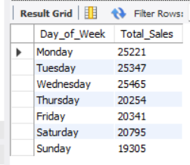

***TO GET SALES FOR ALL HOURS FOR MONTH OF MAY***

SELECT

HOUR(transaction_time) AS Hour_of_Day,

ROUND(SUM(unit_price * transaction_qty)) AS Total_Sales

FROM

coffee_shop_sales

WHERE

MONTH(transaction_date) = 5 -- Filter for May (month number 5)

GROUP BY

HOUR(transaction_time)

ORDER BY

HOUR(transaction_time);

